
FORE SCHOOL OF MANAGEMENT
New Delhi | Gurugram
STREAMING DATA ANALYTICS
ASSIGNMENT 3
Real-Time Retail Transaction
Analytics Dashboard
From Kafka Transaction Streams to a Management Dashboard — A Continuation of “Real-Time Retail Transaction Streaming” (Assignment 2)
Student Name | Sneha Umar Vaishya
Roll Number | 065108
Programme | PGDM (Business Data Analytics), Batch-06
Course | Streaming Data Analytics
Submitted to | Prof. Aditya Dua
Academic Year | 2026
Submission Date | 1 October 2026

Contents
1. Executive Summary 3
2. Introduction 3
3. Problem Statement 4
4. Project Objectives 4
5. Scope of the Project 4
6. Technology Stack 5
7. System Architecture 6
8. Dataset Description 6
9. Assignment 2 to Assignment 3 Integration 8
10. Implementation Methodology 9
11. Dashboard Design 11
12. Dashboard Layout 13
13. Data Analysis and Business Insights 13
14. Key Performance Indicators 17
15. Real-Time Analytics Perspective 17
16. Business Applications 18
17. Challenges and Limitations 19
18. Recommendations 20
19. Future Scope 20
20. Conclusion 21
21. References 21
Appendix 23

1. Executive Summary
Retail organisations generate transaction data continuously, yet many still depend on periodic reports that reveal a sales problem only after the opportunity to respond has passed. This project addresses that gap in a simulated consumer-electronics and retail environment by converting a stream of point-of-sale (POS) events into a management dashboard.
Assignment 2 built the ingestion layer: 100 validated POS transactions were serialised as JSON by a Python producer and published to the retail-transactions topic on Apache Kafka, running in Docker, where a console consumer independently confirmed 100 messages. Assignment 3 extends that foundation downstream. A Python Kafka consumer subscribes to the same topic, reads each transaction event and writes it to a MySQL database running in Docker. The consumer reported 100 Kafka messages transferred, and a SQL count independently confirmed 100 stored records. Grafana, connected to MySQL through a verified data source, then turns the stored records into KPI cards and charts. MongoDB Atlas was also configured and trialled as a storage target; the final analytical store is MySQL (Sections 6 and 17, Appendix).
The dashboard reports total revenue of ₹1.97 million from 100 transactions and 194 units, an average transaction value of about ₹19.7 thousand. Revenue is highly concentrated: Electronics contributes ₹1,654,959, or roughly 84% of revenue, against Home (₹151,953), Fashion (₹99,351) and Beauty (₹67,451). Store S002 recorded the most transactions, and credit-card payments carry the largest payment share at 35%.
These indicators matter because revenue, transaction count, quantity, category mix and store performance are the levers through which a retail manager allocates inventory, promotions and attention. When such measures are available soon after each sale, a manager can notice a shift in category or store performance while it is still correctable, rather than in a next-day report, which is the decision scenario defined for the Category / Sales Manager persona in Assignment 1.
The refresh behaviour must be described accurately. The consumer reads events from Kafka as a bounded run that stops after the 100 test messages; the dashboard shows whatever is stored in MySQL at the time Grafana queries it. The architecture is therefore event-driven and capable of near-real-time operation, but the demonstration is a replay of a small simulated dataset, not a live POS feed.
The purpose of Assignment 3 is to transform streamed transaction data into an analytical dashboard that supports managerial decision-making.

2. Introduction
Retail has become a data-driven business. Every scan at a point of sale records what was sold, where, when, at what price and how it was paid for. In consumer-electronics retail these events carry unusually high value per transaction, so a small number of purchases can move daily revenue materially, and the cost of a late reaction, such as a stock-out on a premium product or a stalled promotion, is correspondingly high.
Traditional reporting is batch-based: transactions accumulate in operational systems, are extracted overnight, and reach management as a daily or weekly report. This is adequate for retrospective review but weak for operational control, because by the time a pattern appears in the report the day’s trading window has closed. Batch reporting also encourages manual extraction and spreadsheet consolidation, which introduces delay and inconsistency.
Streaming analytics treats each transaction as an event that is published the moment it occurs, buffered durably by a messaging platform, and consumed by downstream applications independently (Narkhede, Shapira, & Palino, 2017; Kleppmann, 2017). Dashboards built on that stream give management a current, shared view of performance and shorten the interval between event and decision. Good dashboard design also matters: a dashboard should present a small number of well-chosen measures so that the reader can act on them quickly (Few, 2013).
This project demonstrates the complete path in miniature: simulated POS transactions are produced into Kafka, consumed by a Python application, persisted in a relational database, and visualised in Grafana. Assignment 1 defined the pipeline conceptually, Assignment 2 implemented the Kafka ingestion stage, and Assignment 3 completes the journey to management insight.

3. Problem Statement
Retail organisations generate continuous transaction data, but without a real-time analytics pipeline, managers may struggle to monitor sales performance, revenue trends, product categories and transaction patterns promptly. Insight arrives late, is assembled manually, and often reflects a different version of the data for each reader.
In this project the problem takes a concrete form. After Assignment 2, 100 POS transactions existed as messages on the retail-transactions Kafka topic and could be read by a console consumer, but they were not stored in an analytical structure and no business view existed on top of them. A manager could not ask how much revenue had been earned, which category or store was driving it, or how customers were paying.
Problem to be solved
How can transactions streamed through Kafka be consumed, stored in a queryable form, validated, and presented as KPIs and charts so that a retail manager can monitor revenue, transactions, quantity, category mix and store performance and act on them?

4. Project Objectives
- To consume real-time retail transaction data from the retail-transactions topic using Apache Kafka and a Python consumer.
- To process and store the consumed transaction data in a database that supports SQL analysis.
- To organise streaming data into a structured schema suitable for analytics.
- To monitor transaction and revenue performance through headline KPIs.
- To identify high-performing product categories and stores.
- To develop an interactive analytical dashboard connected to the stored data.
- To derive business insights from streaming transaction data and link them to managerial decisions.

5. Scope of the Project
The project covers POS retail transactions for a simulated consumer-electronics and general retail business with three stores (S001–S003) and four product categories (Electronics, Home, Fashion and Beauty). Within that setting, the scope includes the following stages.
- Streaming data ingestion: 100 transaction records read from a CSV file and published to Kafka (Assignment 2).
- Kafka-based communication: the retail-transactions topic as the decoupling layer between producer and consumer.
- Data consumption: a Python consumer that reads each message and transfers it to storage.
- Storage: a MySQL transactions table in the retail_streaming database; MongoDB Atlas was configured and trialled as an alternative target.
- Dashboard creation and business analytics: Grafana panels for KPIs, category, store, payment and price–quantity analysis.

Limitations of scope
The dataset is simulated and contains only 100 transaction records, created for academic purposes. It is not drawn from a live POS system, covers no customer, inventory, margin or discount data, and is too small for statistical inference or forecasting. Findings should be read as a demonstration of the analytical method rather than as evidence about a real retailer.

6. Technology Stack
Table 1: Technologies used and their purpose
Technology | Purpose in this project | Interaction with other components
Python | Dataset generation and validation (Assignment 2); Kafka producer and Kafka consumer scripts | Producer reads CSV and writes to Kafka; consumer reads Kafka and writes to the database
CSV / JSON | CSV holds the initial 100-record dataset; JSON is the message format on Kafka | CSV is the producer’s input; JSON messages are decoded by the consumer
Apache Kafka | Event-streaming platform; topic retail-transactions (1 partition, replication factor 1) | Receives producer messages and serves them to the consumer; broker exposed on host port 9094
Docker | Runs the Kafka broker and the MySQL server (container sda-mysql-a3) in a reproducible local environment | Containers are reached from host-side Python and from Grafana
MySQL 8.4 (Community) | Analytical store: database retail_streaming, table transactions | Written by the consumer; queried by Grafana
Grafana | Dashboard and visualisation layer; data source Assignment3-MySQL | Runs SQL against MySQL to build KPI cards and charts
MongoDB Atlas / PyMongo | Cloud document database (Cluster0) configured and trialled as a storage target | Consumer-to-Atlas write was attempted; see Section 17 and Appendix
VS Code | Development and terminal environment | Used to run scripts and capture evidence

The technologies form a chain. Python moves data from a file into Kafka and later from Kafka into MySQL; Kafka decouples these two steps so that the producer does not need to know who consumes the data; Docker packages the infrastructure; and Grafana reads only from the database, so dashboard users never touch the streaming layer. MySQL was adopted as the final store because Grafana provides a built-in MySQL data source with SQL-based aggregation (Grafana Labs, n.d.), which suits the KPI and group-by analysis required here.

7. System Architecture
The end-to-end flow extends the Assignment 2 pipeline with a storage and visualisation layer.
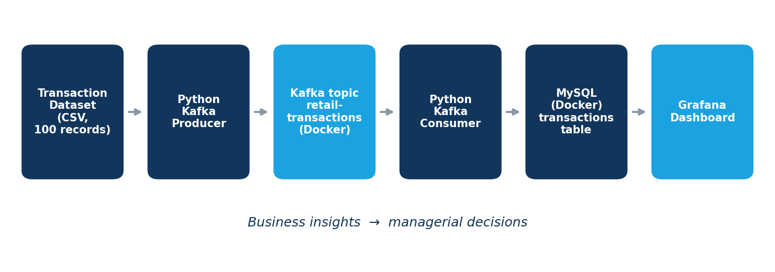
Figure 1: End-to-End Streaming Data Architecture
Table 2: Architecture components and data flow
Component | Role in the flow
Transaction dataset | 100 simulated POS records in CSV with a fixed nine-field schema; validated at source (total_amount = quantity × unit_price).
Python Kafka producer | Reads each record, serialises it to JSON and publishes it to Kafka; displays topic, partition and offset for each acknowledgement.
Kafka topic: retail-transactions | Durable, ordered log of transaction events (one partition), the decoupling point between producer and consumer.
Python Kafka consumer | Subscribes to the topic, decodes each message, writes it to MySQL and prints progress (n/100, transaction ID, amount); stops after 100 messages.
MySQL (retail_streaming.transactions) | Relational store with transaction_id as primary key; the single source of truth for analytics.
Analytics layer | SQL aggregations (SUM, COUNT, GROUP BY) executed by Grafana against MySQL to produce KPIs and chart series.
Dashboard (Grafana) | KPI cards, bar charts, donut chart, scatter plot, table and gauge presented to management.
Business insights | Interpretation of the dashboard to support inventory, promotion and store decisions.

8. Dataset Description
The dataset consists of 100 simulated POS transactions generated in Python for Assignment 2. The records represent purchases across three stores and four product categories. The data is simulated for academic purposes and does not describe any real retailer or customer. The MySQL table holds nine fields: the eight fields in the project brief plus payment_method, which was present in the Assignment 2 schema and is used in the payment-mix analysis.
Table 3: Transaction schema and business meaning
Field | MySQL data type | Business meaning
transaction_id | VARCHAR(20), primary key | Unique identifier of a sale (e.g. T079); the basis for counting transactions and preventing duplicates.
timestamp | DATETIME | Date and time of the sale; enables trend and time-of-day analysis.
store_id | VARCHAR(20) | Store where the sale occurred (S001, S002, S003); enables store comparison.
product_id | VARCHAR(20) | Identifier of the product sold; enables product-level analysis.
category | VARCHAR(50) | Product group (Electronics, Home, Fashion, Beauty); enables category mix analysis.
quantity | INT | Units sold in the transaction; a volume measure.
unit_price | DECIMAL(10,2) | Price per unit in rupees (₹).
total_amount | DECIMAL(12,2) | Transaction revenue; equals quantity × unit_price.
payment_method | VARCHAR(30) | Payment instrument used (Credit Card, UPI, Card, Debit Card).
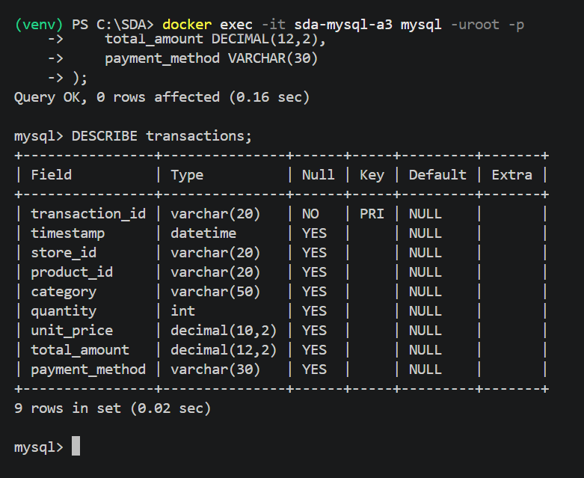
Figure 2: MySQL transactions table schema (DESCRIBE transactions) for real-time retail transaction data

Representative records
The consumer terminal output (Figure 3) displays the transaction ID and total amount for each record as it is transferred. The table below reproduces a representative selection from that output; the remaining fields for these records are held in the CSV and the transactions table.
Table 4: Representative records observed in the consumer output
Transaction ID | Total amount (₹) | Observation
T079 | 1,899 | Low-ticket transaction
T080 | 4,499 | Low-ticket transaction
T084 | 5,598 | Low-ticket transaction
T085 | 86,997 | High-ticket transaction
T086 | 116,997 | High-ticket transaction
T087 | 21,999 | Mid-ticket transaction
T089 | 86,997 | High-ticket transaction
T097 | 128,997 | Highest value among the 22 records visible
T100 | 4,598 | Final record consumed
The sample already shows a feature that shapes the whole analysis: transaction values are strongly skewed, with a few high-ticket purchases alongside many small ones.

9. Assignment 2 to Assignment 3 Integration
Assignment 1 designed a multi-topic streaming pipeline whose final output layer would be a lightweight database driving a dashboard, and stated that this layer would become the data source for Assignment 3. Assignment 2 implemented the ingestion stage for the transaction stream. Assignment 3 implements the storage and analytics stages.
Table 5: How Assignment 3 builds on Assignment 2
Stage | Assignment 2: Streaming ingestion | Assignment 3: Analytics dashboard
Data | Generated and validated 100 POS records; 9-field CSV schema | Reuses the same stream; consumed records validated again in the database
Kafka | Docker Compose broker on port 9094; topic retail-transactions (1 partition, RF 1) | Same broker and topic; no change to producer logic
Producer | Python producer sent 100 JSON messages with topic/partition/offset acknowledgements | Unchanged upstream component
Consumer | Kafka console consumer verified 100 messages processed | Python consumer reads the topic and writes to MySQL; 100/100 transferred
Storage | None; messages remained on the Kafka topic | MySQL transactions table (100 rows); MongoDB Atlas trialled
Analysis | None | Validation, reconciliation, KPI calculation, SQL aggregation
Visualisation | None | Grafana dashboard: KPIs, category, store, payment, price–quantity
Business insight | Business relevance described conceptually | Quantified insights on revenue concentration, store and payment mix

In short, Assignment 2 answered the question “can the data move reliably?”, and Assignment 3 answers “what does the data tell management?”

10. Implementation Methodology

Phase 1 – Data Preparation
A Python script generated 100 POS transaction records and wrote them to a CSV file with nine fields. Before streaming, the script checked that total_amount equals quantity × unit_price for every record; the Assignment 2 validation output confirmed 100 records checked with no calculation errors.

Phase 2 – Kafka Producer
The producer reads the CSV sequentially, converts each row to a JSON message, connects to the broker on host port 9094 and publishes to the topic. Each acknowledgement reports topic, partition and offset, giving traceability. The producer confirmed 100 transactions sent.

Phase 3 – Kafka Topic
The topic retail-transactions is the contract between producer and consumer. It stores events in order and retains them independently of who reads them, so the Assignment 3 consumer can read the same events that the Assignment 2 console consumer read. The topic has one partition and a replication factor of one, appropriate for a single-broker academic environment but not for production.

Phase 4 – Kafka Consumer
The Assignment 3 consumer, consumer.py, connects to the same broker, subscribes to the topic, decodes each JSON message and passes it to the database writer. For each message it prints a progress line in the form “n/100 | transaction ID | ₹amount”. When 100 messages have been processed it prints “Successfully transferred 100 Kafka messages to MySQL. Consumer completed.”
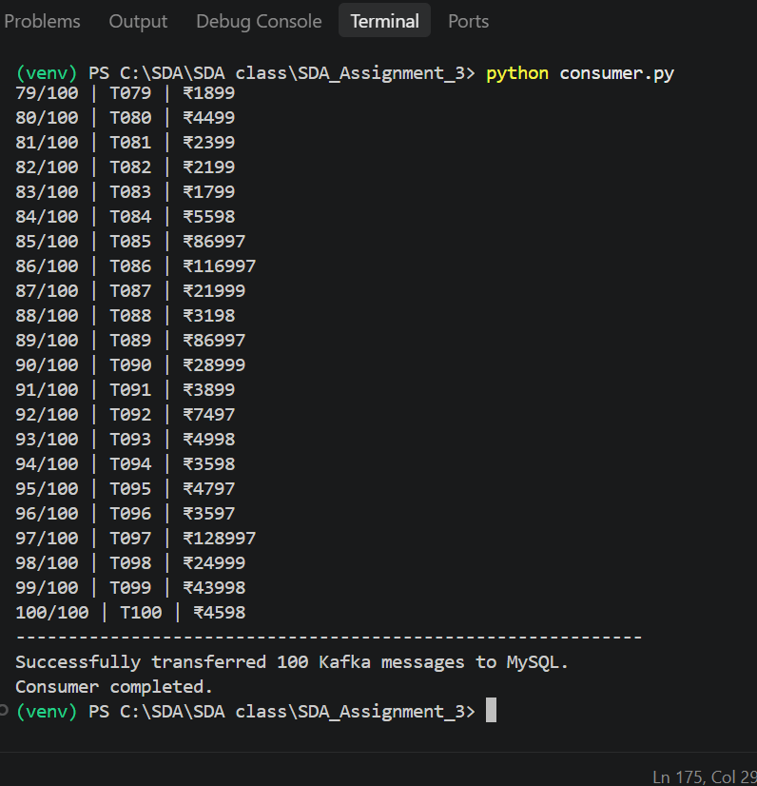
Figure 3: Successful consumption of 100 Kafka transaction events and transfer of data into MySQL

Phase 5 – Storage
Consumed records are inserted into the transactions table of the retail_streaming database in a MySQL 8.4 container (sda-mysql-a3). The primary key on transaction_id means a transaction cannot be stored twice. Verification from the MySQL client returned a count of 100 records.
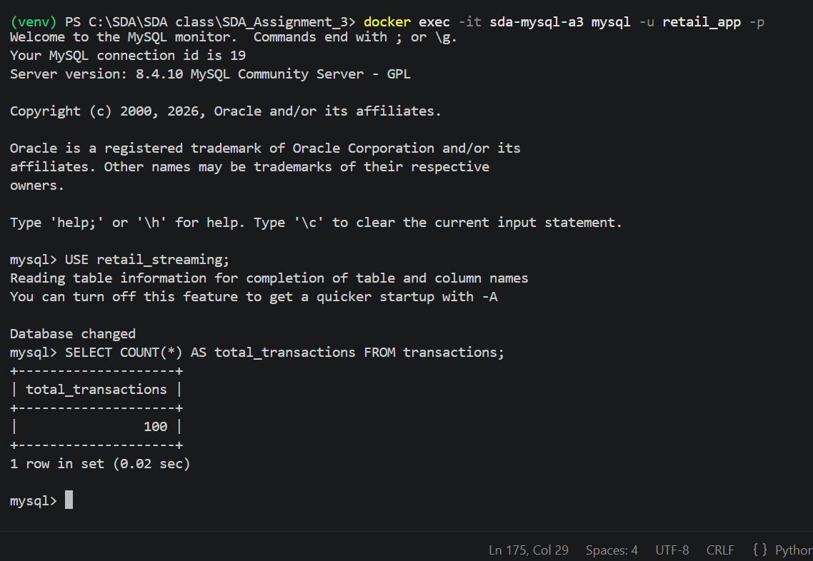
Figure 4: Verification of 100 transaction records stored in MySQL
MongoDB Atlas (Cluster0, PyMongo driver) was configured and a Kafka-to-MongoDB write was attempted; the screenshots are in the Appendix. The pipeline was finalised on MySQL, and the dashboard reads from MySQL only.

Phase 6 – Data Validation
The checks below are those supported by the screenshots and results available for this project.
Table 6: Data validation checks
Check | Method / evidence | Status
Record completeness | 100 sent by producer, 100 processed by console consumer (A2), 100 transferred by Python consumer, COUNT(*) = 100, dashboard Total Transactions = 100 | Passed – evidenced
Duplicate transactions | transaction_id is the primary key; 100 unique records expected and 100 stored | Enforced by schema; count matches
Total amount consistency | Source rule total_amount = quantity × unit_price (A2: 100 checked, no errors). Cross-check: category revenues and payment-method revenues each sum to ₹1,973,714, equal to the dashboard total | Passed – evidenced
Data types | DESCRIBE output confirms datetime, int and decimal types for time, quantity and money fields | Passed – evidenced
Incorrect values | Quantity–unit-price scatter shows quantities of only 1, 2 and 3 and positive prices | No anomalies visible
Label consistency | Payment methods include “Card” alongside “Credit Card” and “Debit Card”, which overlap in meaning | Flagged for standardisation

Phase 7 – Dashboard Development
Grafana was connected to MySQL through a data source named Assignment3-MySQL, and the connection test returned “Database Connection OK”. Each panel is driven by a SQL query: KPI cards use SUM and COUNT over the table, and category, store and payment charts use GROUP BY aggregation. Illustrative queries are in Appendix B.
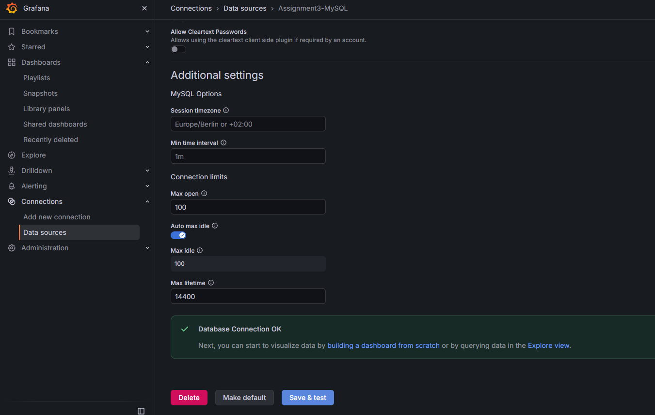
Figure 5: Successful Grafana connection to the MySQL database

11. Dashboard Design
The dashboard follows a top-down logic: headline KPIs first, then breakdowns that explain them. Every panel is intended to answer a specific managerial question. The table below lists the panels captured in the Grafana dashboard.
Table 7: Panels implemented in the Grafana dashboard
Panel | Type | Question answered
Total Revenue | KPI card | How much revenue has been earned?
Total Transactions | KPI card | How many sales have occurred?
Total Units Sold | KPI card | What was the sales volume?
Average Transaction Value | KPI card; gauge | How valuable is a typical sale?
Revenue by Category | Horizontal bar | Which categories generate the revenue?
Transactions by Store | Bar | Which stores handle the most sales?
Revenue by Payment Method | Donut | How do customers pay, and what share of revenue does each method carry?
Quantity vs Unit Price | Scatter | How do price level and basket quantity relate across categories?
Store Revenue Mix by Category | Table | How does each store’s revenue split across categories?
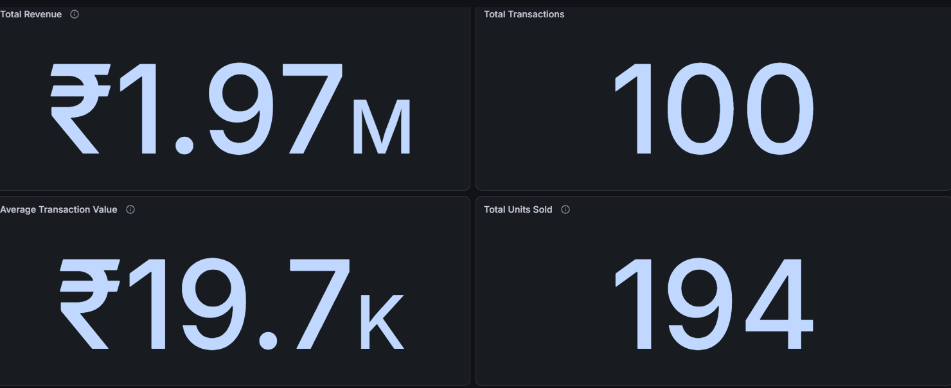
Figure 6: Dashboard KPI cards: Total Revenue, Total Transactions, Average Transaction Value and Total Units Sold
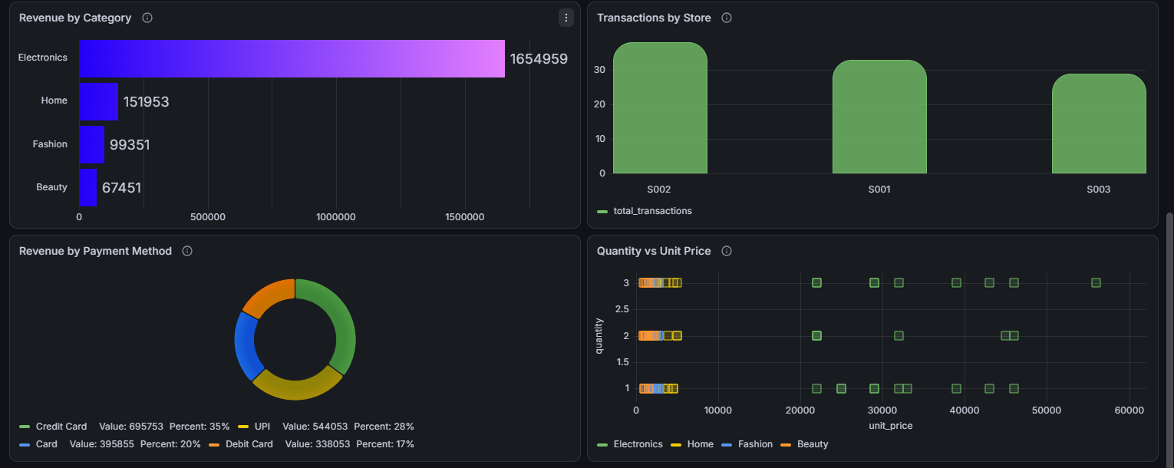
Figure 7: Dashboard panels: Revenue by Category, Transactions by Store, Revenue by Payment Method, Quantity vs Unit Price
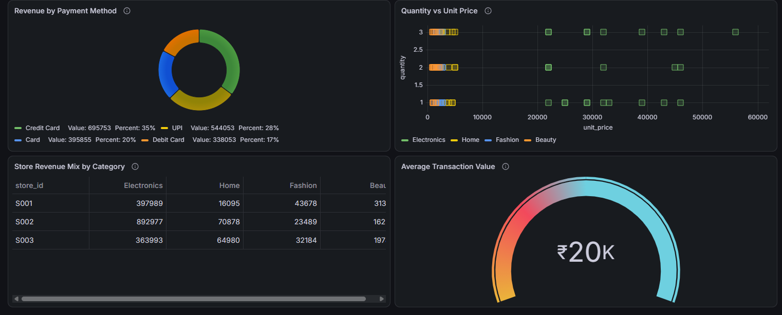
Figure 8: Dashboard panels: Revenue by Payment Method, Quantity vs Unit Price, Store Revenue Mix by Category and Average Transaction Value (some panels overlap with the previous figure)
Panels were chosen for decision value rather than decoration: a bar chart for categorical comparison, a donut only where there are four slices, a scatter plot where two numeric variables are compared, and a gauge for a single benchmark value.

12. Dashboard Layout
The captured dashboard is organised in horizontal bands, reading from summary to detail.
Table 8: Dashboard layout
Band | Panels present | Purpose
Top: KPI cards | Total Revenue, Total Transactions, Average Transaction Value, Total Units Sold | Instant health check of the business
Middle: comparison | Revenue by Category, Transactions by Store | Where revenue and activity are concentrated
Lower: mix and behaviour | Revenue by Payment Method, Quantity vs Unit Price | Customer payment behaviour and price–quantity pattern
Bottom: detail | Store Revenue Mix by Category (table), Average Transaction Value (gauge) | Store-level drill-down and benchmark

Filters. Grafana supports a time-range picker and dashboard variables. Recommended filters for this dashboard are date, category, store and product; the screenshots do not show whether these were configured, so they are stated here as design recommendations rather than as delivered features.
Refresh behaviour. Grafana executes its SQL queries when the dashboard loads or refreshes, according to the dashboard’s refresh setting. Because the consumer in this demonstration ran to completion after 100 messages, the dashboard shows a stable set of 100 records. If the consumer were left running against a live feed, new rows would appear in MySQL and be reflected at the next dashboard refresh, so the dashboard is best described as near-real-time with periodic refresh, not instantaneous.

13. Data Analysis and Business Insights
This section interprets each view in three steps: what the chart shows, why it matters, and what decision it supports. All figures quoted come from the dashboard screenshots; derived percentages are calculated from those values.

13.1 Headline KPIs
Table 9: Headline KPI results and derived ratios
Measure | Value | Source
Total revenue | ₹1,973,714 (dashboard: ₹1.97M) | Sum of category and of payment-method revenue
Total transactions | 100 | Dashboard card
Total units sold | 194 | Dashboard card
Average transaction value | ₹19,737 (dashboard: ₹19.7K) | ₹1,973,714 ÷ 100
Average units per transaction | 1.94 | 194 ÷ 100
Average revenue per unit | ≈ ₹10,174 | ₹1,973,714 ÷ 194

What it shows. A business of 100 sales and nearly two lakh rupees per ten transactions, with fewer than two units in a typical basket. Why it matters. The gap between the average basket value and the average unit price indicates a mix of high-priced and low-priced items. Decision supported. These values serve as the baseline against which later periods, stores or promotions can be compared.

13.2 Revenue by Category
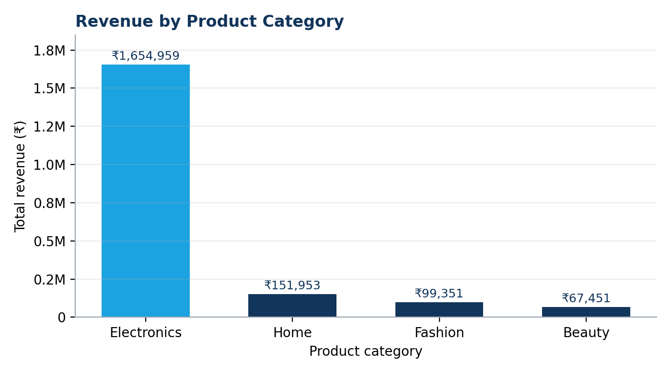
Figure 9: Revenue by product category (reproduced from dashboard values; see Figure 7 for the Grafana panel)
What it shows. Electronics earned ₹1,654,959, far ahead of Home (₹151,953), Fashion (₹99,351) and Beauty (₹67,451). Electronics alone is about 84% of revenue, and the other three categories together are about 16%.
Why it matters. Revenue is heavily concentrated in one category, so overall performance is highly sensitive to Electronics: a stock-out, price change or demand dip there would move the total far more than any change elsewhere.
Decision supported. Inventory priority, working capital and promotional budget should be weighted towards Electronics availability, while the smaller categories are assessed on a different role, such as footfall driver or margin contributor, once margin data is available.

13.3 Category Revenue Contribution
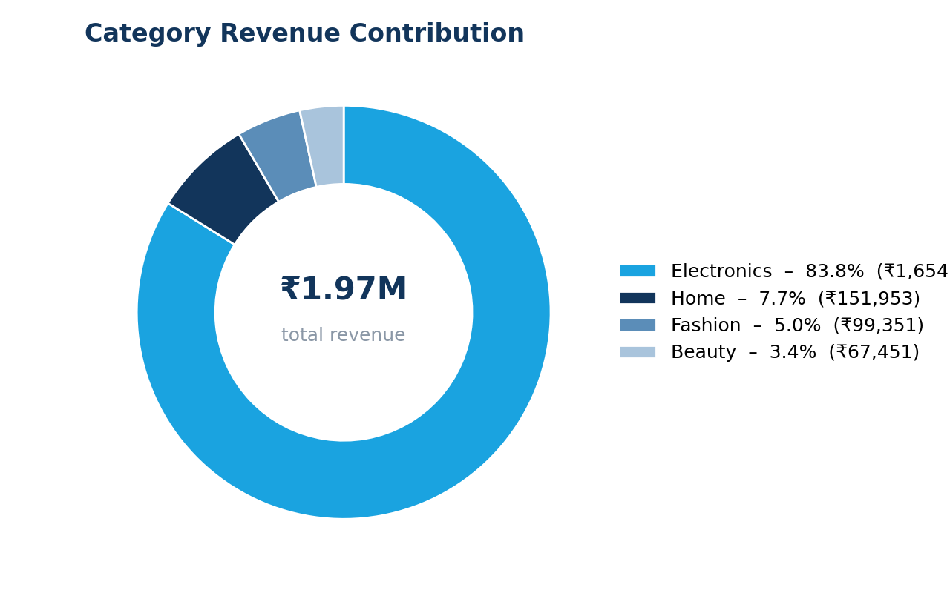
Figure 10: Category revenue contribution (share of total revenue)
What it shows. The same data as a share of the whole: Electronics 83.9%, Home 7.7%, Fashion 5.0%, Beauty 3.4%. With four categories the donut remains readable. Why it matters. It communicates dependence on a single category at a glance, which suits a management summary. Decision supported. Category diversification targets and a watch-list threshold, for example an alert if Electronics share moves materially.

13.4 Transactions and Revenue by Store
What the Transactions by Store panel shows. Store S002 recorded the most transactions, followed by S001 and then S003. What the Store Revenue Mix table adds. S002 earned ₹892,977 of Electronics revenue, 54% of the category total, against ₹397,989 (24%) at S001 and ₹363,993 (22%) at S003.
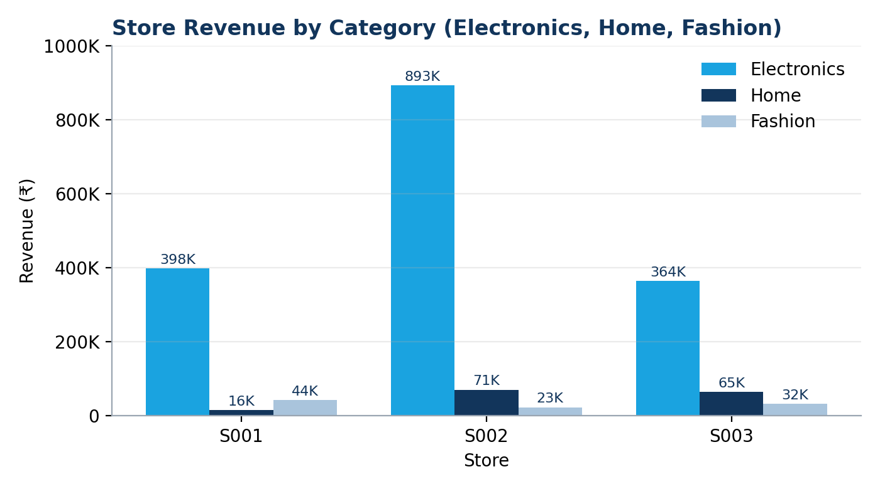
Figure 11: Store revenue by category for Electronics, Home and Fashion (Beauty is truncated in the dashboard table and is not plotted)
The pattern differs by category. S002 leads strongly in Electronics and Home (₹70,878), while S001 is strongest in Fashion (₹43,678, 44% of Fashion revenue), and S003 is second in both Home and Fashion.
Why it matters. S002 combines the highest transaction count with the largest Electronics revenue, which makes it the store whose performance most affects the company total. The stores also show different category strengths. Decision supported. Allocate high-value Electronics stock and demonstrator staff to S002, examine why S001 and S003 convert fewer Electronics sales, and use S001’s Fashion strength to guide local assortment and promotion.

13.5 Revenue by Payment Method
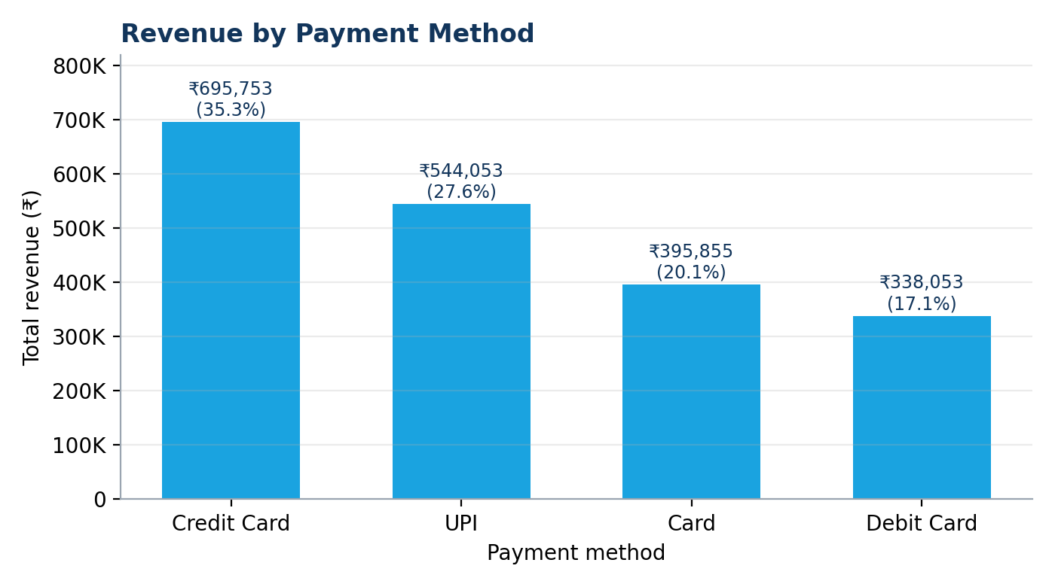
Figure 12: Revenue by payment method
What it shows. Credit Card carries ₹695,753 (35%), UPI ₹544,053 (28%), Card ₹395,855 (20%) and Debit Card ₹338,053 (17%). Credit Card and UPI together account for about 63% of revenue.
Why it matters. Payment mix affects processing cost, cash-flow timing and the design of payment-linked offers. Credit-card dominance in a high-ticket category is consistent with instalment or EMI-style purchasing, although this dataset cannot confirm that. Decision supported. Target card-linked or UPI-linked promotions on the methods customers already use, and negotiate payment-processing terms accordingly. The separate label “Card” overlaps with “Credit Card” and “Debit Card”, so the payment_method values should be standardised before the split is relied on.

13.6 Quantity versus Unit Price
What it shows. Quantity per transaction takes only the values 1, 2 and 3. Electronics unit prices are spread from roughly ₹22,000 to ₹56,000, while Home, Fashion and Beauty items cluster at low prices, broadly below ₹6,000. Quantities of 2 and 3 occur mainly at low prices, though Electronics also appears at all three quantity levels.
Why it matters. Because quantity is capped at three, revenue per transaction is driven mainly by unit price, not basket size. That explains why Electronics, with a few high-priced units, dominates revenue. Decision supported. Revenue growth in Electronics depends on converting more high-ticket purchases, while growth in the smaller categories depends on raising basket size through bundles or multi-buy offers.

13.7 Average Transaction Value
What it shows. An average transaction value of about ₹20K on the gauge (₹19,737 exactly). Why it matters. The average is pulled upwards by a minority of very large transactions: among the 22 consumer-output records visible in Figure 3, four exceed ₹86,000 (T085, T086, T089, T097) while most are below ₹10,000. A typical sale is therefore smaller than the average suggests. Decision supported. Management should track the median and the distribution alongside the mean, and set targets by category, not on a single blended average.

13.8 Summary of Insights
- Revenue is highly concentrated in Electronics (≈84%), so availability and pricing in that category govern overall performance.
- Store S002 is the key store for both transaction volume and Electronics revenue.
- Transaction values are skewed by a few high-ticket sales, so the average overstates a typical basket.
- Credit Card and UPI carry about 63% of revenue; payment labels need standardising.
- Quantity per sale is low (1 to 3), so growth in smaller categories depends on basket-building.

14. Key Performance Indicators
The dashboard KPIs are simple aggregations, which keeps them transparent and reproducible. Each is defined below with its relevance to retail management.
Table 10: KPI definitions
KPI | Formula | Value | Relevance to management
Total Revenue | Sum of total_amount | ₹1.97M | Overall sales performance; the base for every ratio
Total Transactions | Count of unique transaction_id | 100 | Activity level and footfall proxy; denominator for average value
Total Quantity Sold | Sum of quantity | 194 | Sales volume; links to stock consumption and replenishment
Average Transaction Value | Total Revenue ÷ Total Transactions | ₹19.7K | Basket value; indicates pricing, mix and upselling effectiveness
Number of Product Categories | Count of distinct category | 4 | Breadth of the active assortment

Using COUNT of unique transaction_id guards against double counting if the same event were delivered twice, which is a known behaviour of at-least-once delivery in messaging systems (Narkhede et al., 2017). In this project the primary key already prevents duplicate rows.

15. Real-Time Analytics Perspective
A conventional BI dashboard is typically fed by a scheduled extract; the data it shows is as old as the last load. This project differs in architecture. Transactions are modelled as events, published to Kafka when they occur, and consumed independently by a separate application that writes them to the analytical store. The characteristics that make it a streaming-analytics design are listed below.
- Continuous data generation: POS sales are an unbounded sequence of events, not a periodic file.
- Event-driven architecture: the producer publishes events without knowing who will use them, and any number of consumers can read the same topic.
- Kafka message streaming: the topic retains events in order, with offsets that make each message traceable.
- Consumer processing: each message is decoded and written as it is read, not in a nightly load.
- Near-real-time availability: once a row is written to MySQL, the next dashboard query includes it.
- Continuous updates and less manual reporting: no manual extraction or spreadsheet consolidation is required between sale and dashboard.
- Faster decisions: the delay between event and insight shrinks from a reporting cycle to a refresh interval.
Accurate statement of what was demonstrated
The consumer was run as a bounded job that stopped after 100 messages, and Grafana refreshes by query. The implementation therefore demonstrates the streaming architecture and near-real-time capability, not a continuously running live feed. A continuously running consumer and an automatic dashboard refresh interval would be needed for live operation.

Table 11: Batch analytics versus streaming analytics
Dimension | Batch analytics | Streaming analytics (this project)
Data handling | Data accumulated, then processed in bulk | Each event processed as it arrives
Latency | Hours to days | Seconds to minutes, depending on consumer and refresh
Architecture | Scheduled extract–transform–load | Producer → broker → consumer → store
Decision window | Retrospective review | Operational, while the situation is unfolding
Manual effort | Report preparation and consolidation | Largely automated after setup
Complexity | Lower | Higher: brokers, offsets, delivery guarantees
Best suited to | Historical and regulatory reporting | Monitoring, alerts and rapid response

16. Business Applications
In a real consumer-electronics retailer, replacing the simulated CSV with live POS events would let the same architecture support the following applications.
Table 12: Business applications of the architecture
Application | How the architecture supports it
Real-time sales monitoring | KPI cards updated as sales are consumed; deviation from the expected run-rate becomes visible within the refresh interval.
Inventory planning | Category and product sales velocity feeds replenishment, especially for high-value Electronics where stock-outs are costly.
Product performance monitoring | Revenue and quantity by product_id identify fast and slow movers.
Store performance | Store-level revenue and category mix (as in Section 13.4) support store comparisons and local assortment.
Promotional analysis | Before-and-after revenue around a promotion can be read directly from the timestamped stream.
Demand monitoring | Sudden changes in category volume signal demand shifts; the revenue-drop alert defined in Assignment 1 would build on this.
Revenue tracking | Cumulative and hourly revenue against targets.
Operational decision-making | Staffing, stock transfers and escalation of checkout or site problems based on current rather than next-day data.

17. Challenges and Limitations
The table separates challenges that were encountered in this project, as documented in the screenshots or the earlier reports, from challenges that are potential in a real deployment.
Table 13: Challenges and limitations
Challenge | Nature | Comment
Simulated dataset | Known limitation | Records are synthetic; findings illustrate method, not real retail behaviour.
Limited number of records | Known limitation | 100 records are too few for trend analysis, forecasting or statistical testing.
Lack of actual live POS data | Known limitation | No real-time feed was available; the stream is a replay of a CSV.
Kafka configuration | Encountered in Assignment 2 | A port conflict with another Kafka container was resolved by a dedicated instance on host port 9094, with listener configuration adjusted for host and container access.
MongoDB integration | Encountered in Assignment 3 | A consumer run targeting MongoDB Atlas reported 0 transactions consumed and ended with a traceback raised from the PyMongo update call (Figure A2). The screenshot is truncated, so the root cause is not stated here. The pipeline was finalised on MySQL.
Consumer connectivity | Potential | Network, authentication or offset settings can prevent a consumer from reaching or reading a topic.
Data consistency | Potential | Duplicate delivery, schema drift or inconsistent labels (e.g. “Card” versus “Credit Card”) can distort KPIs.
Dashboard refresh limitations | Potential | Dashboards refresh by query on an interval, so they are near-real-time, not instantaneous.
Single-node infrastructure | Known limitation | One broker, one partition and one database container give no fault tolerance.

18. Recommendations
Based on the analytical framework, the following steps would move the solution from a demonstration to a decision-support system.
- Integrate with actual POS systems so that the topic receives live events instead of a CSV replay.
- Run the consumer continuously and set an explicit Grafana refresh interval so the dashboard updates without manual action.
- Increase transaction volume and history to allow reliable trend and seasonality analysis.
- Add inventory, customer, product-margin and promotion/discount data so that revenue can be tied to stock, profitability and campaign effects.
- Standardise reference data, such as payment-method labels, and enforce NOT NULL constraints on fields required for analysis.
- Extend the dashboard with a revenue trend over time and category-level views of transactions, quantity and average transaction value.
- Implement anomaly detection and real-time alerts, beginning with the revenue-drop and low-stock alerts specified in Assignment 1.
- Apply least-privilege database access for the application user and avoid administrative accounts in routine operation.
- Deploy cloud-based, multi-broker streaming infrastructure with replicated partitions for resilience.

19. Future Scope
The table separates what has been implemented from what is proposed. Items in the right-hand column are not part of the current implementation.
Table 14: Current implementation versus future enhancements
Area | Current implementation | Future enhancement
Stream processing | Python consumer with row-by-row writes | Apache Spark Streaming or Kafka Streams for windowed aggregation
Analytics | SQL aggregation of stored records | Machine learning and demand forecasting
Risk | Manual validation checks | Fraud and anomaly detection on the stream
Customers | Not covered | Customer segmentation using customer data
Inventory | Not covered | Predictive inventory management
Alerting | Visual dashboard only | Real-time alerts on revenue drops and stock thresholds
Deployment | Local Docker containers | Cloud deployment with managed Kafka and database
BI tools | Grafana | Power BI or Tableau integration for enterprise reporting

20. Conclusion
This project demonstrates the complete journey from data to streaming to processing to storage to visualisation to insight to decision. It began with 100 simulated POS transactions, validated at source. In Assignment 2 those transactions were serialised and published to the retail-transactions topic on Apache Kafka, where an independent consumer confirmed that all 100 messages were available. In Assignment 3, a Python consumer read the same topic and transferred 100 of 100 messages into a MySQL table, a SQL count confirmed 100 stored records, and Grafana turned the stored data into a dashboard.
The dashboard converts raw events into measures a manager can use. Total revenue of ₹1.97 million, 100 transactions, 194 units and an average transaction value of about ₹19.7 thousand give the baseline. The breakdowns add the explanation: Electronics contributes about 84% of revenue, store S002 leads on both transactions and Electronics revenue, credit-card and UPI payments carry about 63% of revenue, and a few high-ticket sales lift the average well above a typical basket. Each finding maps to a decision on inventory priority, store allocation, payment-linked promotion or target-setting.
The project is also candid about its boundaries. The data is simulated, the stream is a bounded replay of 100 records, the dashboard refreshes by query, and the dashboard covers revenue, store, payment and price–quantity views rather than a time-based trend. A MongoDB Atlas storage route was configured and trialled, but the final, evidenced pipeline uses MySQL. These limits do not weaken the central result: the architecture is sound, each stage is verified by evidence, and it can be scaled by replacing the simulated source with live POS events and running the consumer continuously.
Most importantly, Assignment 3 transforms the technical Kafka pipeline developed in Assignment 2 into a management-oriented analytics solution. Assignment 2 proved that transaction data could move reliably; Assignment 3 shows what that data means for revenue, categories, stores and customers, and how management can act on it. That shift from moving data to using data is the essence of streaming data analytics.

21. References
Akidau, T., Bradshaw, R., Chambers, C., Chernyak, S., Fernández-Moctezuma, R. J., Lax, R., McVeety, S., Mills, D., Perry, F., Schmidt, E., & Whittle, S. (2015). The dataflow model: A practical approach to balancing correctness, latency, and cost in massive-scale, unbounded, out-of-order data processing. Proceedings of the VLDB Endowment, 8(12), 1792–1803.
Apache Software Foundation. (n.d.). Apache Kafka documentation. https://kafka.apache.org/documentation/
Docker, Inc. (n.d.). Docker documentation. https://docs.docker.com/
Few, S. (2013). Information dashboard design: Displaying data for at-a-glance monitoring (2nd ed.). Analytics Press.
Grafana Labs. (n.d.). MySQL data source. Grafana documentation. https://grafana.com/docs/grafana/latest/datasources/mysql/
kafka-python. (n.d.). kafka-python documentation. https://kafka-python.readthedocs.io/
Kleppmann, M. (2017). Designing data-intensive applications: The big ideas behind reliable, scalable, and maintainable systems. O’Reilly Media.
MongoDB, Inc. (n.d.). MongoDB Atlas documentation. https://www.mongodb.com/docs/atlas/
MongoDB, Inc. (n.d.). PyMongo documentation. https://pymongo.readthedocs.io/
Narkhede, N., Shapira, G., & Palino, T. (2017). Kafka: The definitive guide: Real-time data and stream processing at scale. O’Reilly Media.
Oracle Corporation. (n.d.). MySQL 8.4 reference manual. https://dev.mysql.com/doc/refman/8.4/en/
Python Software Foundation. (n.d.). Python 3 documentation. https://docs.python.org/3/

Appendix

Appendix A – Supporting Evidence
Figures A1 and A2 show the MongoDB Atlas trial referred to in Sections 6, 10 and 17.
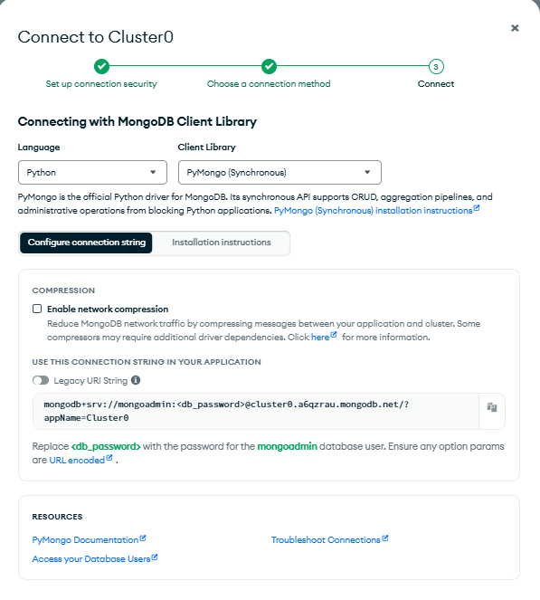
Figure A1: MongoDB Atlas Cluster0 connection options for the Python (PyMongo) driver (credentials are placeholders)
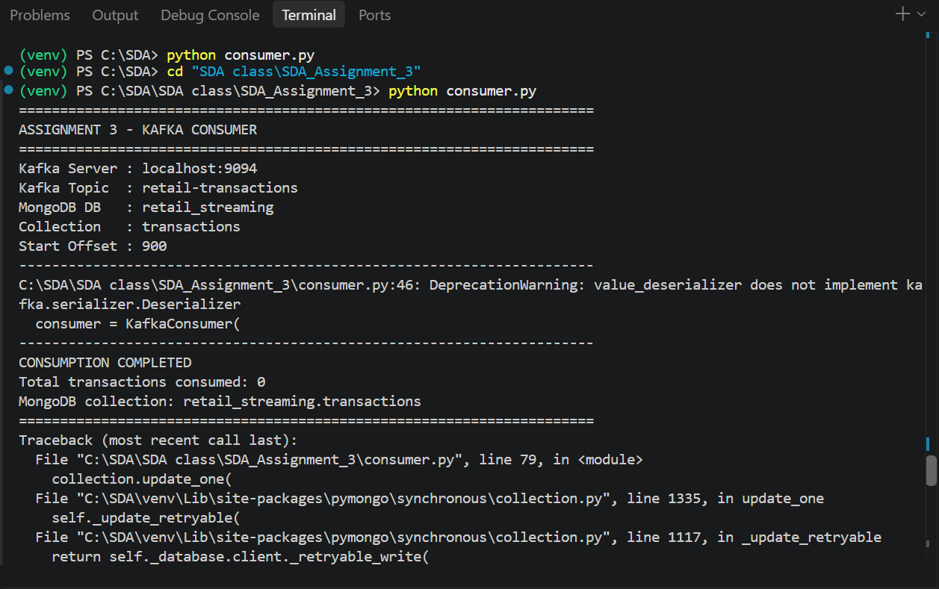
Figure A2: Assignment 3 consumer run targeting MongoDB Atlas: 0 transactions consumed, followed by a traceback from the update call

Appendix B – Illustrative SQL Queries
These illustrative queries are consistent with the transactions schema and show how the headline KPIs and the category analysis can be produced.
-- Headline KPIs
SELECT SUM(total_amount) AS total_revenue,
COUNT(DISTINCT transaction_id) AS total_transactions,
SUM(quantity) AS total_units,
SUM(total_amount) / COUNT(DISTINCT transaction_id) AS avg_transaction_value
FROM transactions;

-- Revenue, transactions and quantity by category
SELECT category, SUM(total_amount) AS revenue,
COUNT(*) AS transactions, SUM(quantity) AS units,
AVG(total_amount) AS avg_transaction_value
FROM transactions GROUP BY category ORDER BY revenue DESC;

